MAINTAIN

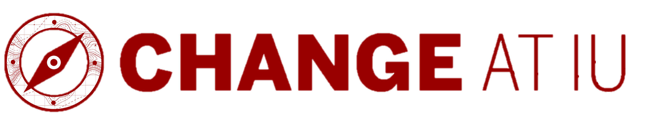
Specify how to sustain the new standard.
Evaluate Outcomes What was the outcome of your goals, success measures and milestones?
Indicators (goals, measures, milestones) | Timing | What was the outcome? | What actions are needed, if any?

Check In How are people feeling now?
Audience | How to gather input | Timing | What did you learn? | What actions are needed, if any?

Recognize Contributions How will you recognize contributions in ways meaningful to your team and individuals?
Individual/Team | Contributions | How to Celebrate | Timing

Communicate Impact How will you communicate the impact to your stakeholders?
Audience | Impact/Key Messages | Communication Channel | Timing

Maintain Behaviors/Processes How will you ensure behaviors/processes are maintained over time?
What to maintain | Strategies to do so | Timing

Ongoing Support/Training What ongoing support or training will reinforce the change long term?
Audience | Support/Training Needed | Delivery Method | Timing

Oversee Continuous Improvement Who will oversee continuous improvements?
Person Responsible | What to Review/How | Timing | Action Needed
Thank you for your leadership through this process. Taking on change is no small feat. Your work will provide valuable lessons, regardless of the outcome. For additional resources, contact the Talent & Organization Development team at askHR@iu.edu.

