PLAN

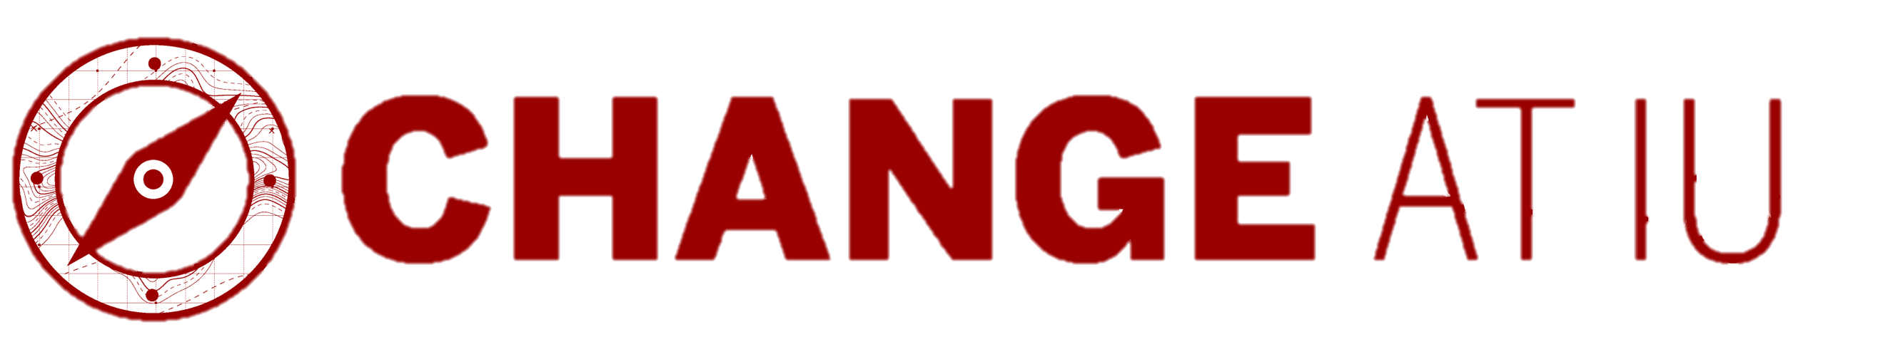
Craft your strategic vision. Identify the key elements of your change initiative by answering the foundational questions below. Your answers will help you create a strategic vision to drive purpose and alignment.

Define What
What is the change? | Goals of the change:
What will be different because of the change? | What will stay the same?

Explain the Why
Reason(s) for change: | Consequence(s) of not changing:

Identify Who
Sponsor(s): | Support needed from them:

Role | Name(s) | How will they be affected? | Feeling about change  e.g., supportive, resistant, undecided | Expectations or support needed  e.g., advice, decision-making, influencing others
Change manager
Project manager
Stakeholders, influencers or others impacted

Determine When
Start date: | Anticipated deadline for completion:
Project phases, if known:

Factors that might affect timing: | Action Needed? (yes or no) If so, explain.

Specify Where (e.g., specific campus, unit, location)
Where will the change occur?

Craft Your Strategic Vision
Based on your responses above, create a strategic vision for the change.

Strategic Vision Tips

- Keep it simple and easy for everyone to understand.
- Make it motivational by focusing on a compelling future.
- Align it with your organization’s long-term goals and values.
- Ensure it is achievable, even if ambitious.

Template

What is the core message you want to communicate? Use this template and key points from your responses to craft your strategic vision. Tailor the template if needed or create your own.
Our vision is to (recap the What):
This vision is crucial because (recap the Why):
Our vision will be driven by our dedicated team and will consist of (recap the Who):
We aim to achieve significant milestones (recap the Where) with a full realization of our vision by (When).
Thank you for your leadership through this process. Taking on change is no small feat. Your work will provide valuable lessons, regardless of the outcome. For additional resources, contact the Talent & Organization Development team at askHR@iu.edu.

